# PROJECT REPORT TEMPLATE

# INTRODUCTION

# 1.1 OVERVIEW

# An ATS is a software application that helps you manage the entire recruitment process, right from receiving resumes to hiring employees. The software helps you automate the process of screening & shortlisting candidates, applicant evaluation, scheduling interviews, managing the hiring process, background verification, and completing new-hire paperwork. ATS helps in sorting through resumes, to determine which ones are the best fit for the open positions. Applicant tracking systems evaluates your resume by checking for keywords or skill sets that fit the job description. The main function of an ATS is to provide a central location and database for a company’s recruitment efforts. ATSs are built to better assist management of resumes and applicant information. Data is either received from internal applications via the ATS front-end, located on the company website or is extracted from applicants on job boards. The majority of job and resume boards (LinkedIn.com, Monster.com,, Indeed.com) have partnerships with ATS software providers to provide integration, parsing support and ease of data migration from one system to another. An ATS is a software application that helps you manage the entire recruitment process, right from receiving resumes to hiring employees.

# 1.2 PURPOSE

An ATS creates opportunities to automate manual processes, increase visibility into the hiring cycle for the entire recruiting team, and increase opportunities for communication throughout the candidate journey. 78% of recruiters using an ATS report that it has improved the quality of the candidates they *hire.*

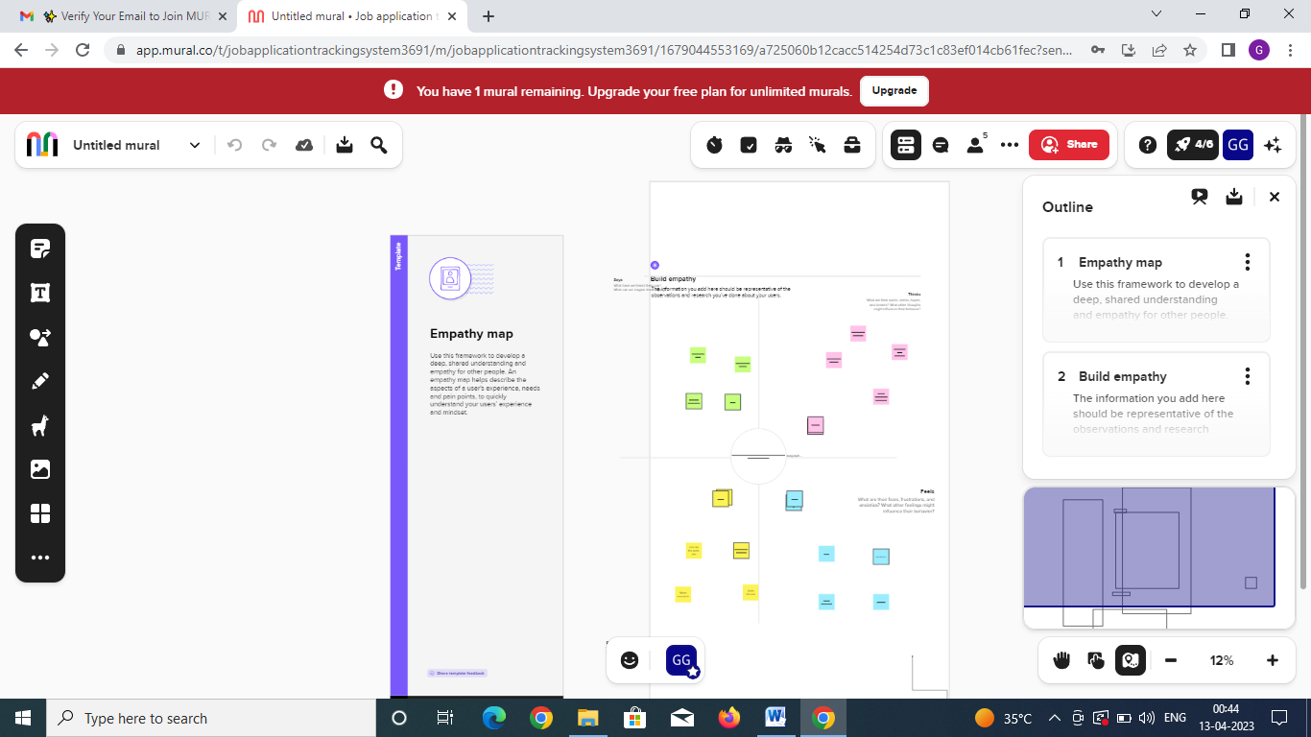

# 

# 

# 3. RESULT

# 3.1 DATA MODEL

|  |  |
| --- | --- |
| OBJECT NAME | FIELDS IN THE OBJECT |
| Object -1 | Field Label: Recruiter **Data type**: Auto Number |
| Object-2 | Field Label: Text **Data type**: Length |
| Object-3 | Field Label: Contact **Date type**: Accounts |

# 3.2 Activity and Screenshot

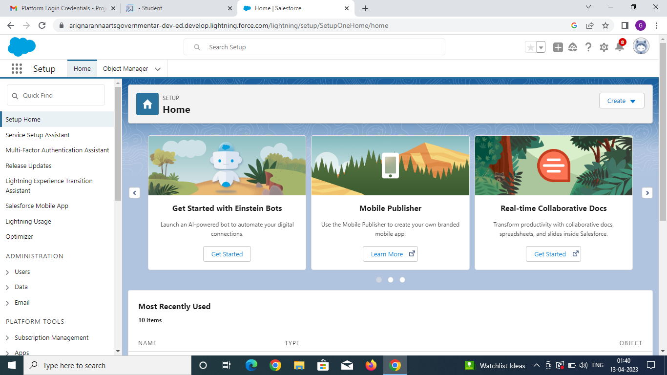

**Create Sales force Org-creating developer account**

**Create a custom object for Recruiter**

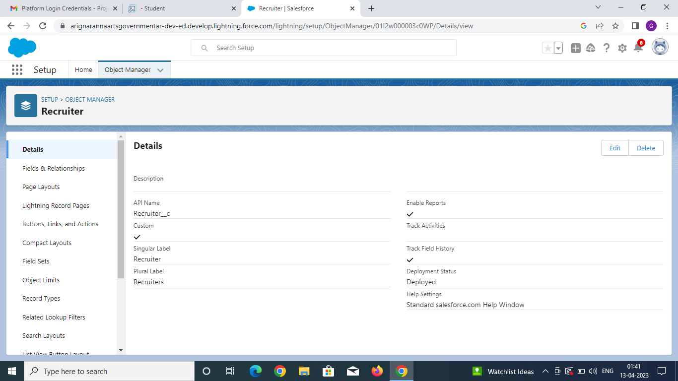

**/**

**Create the custom fields**

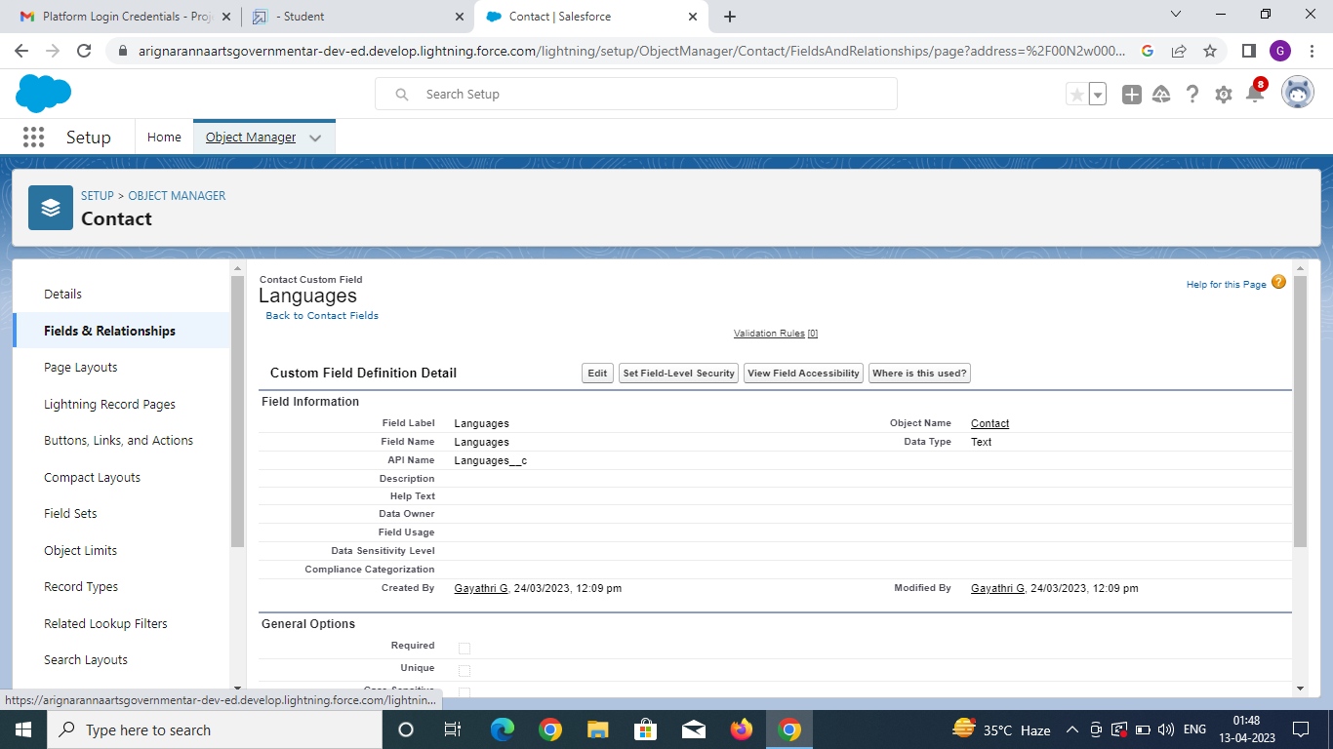

**Create a tab**

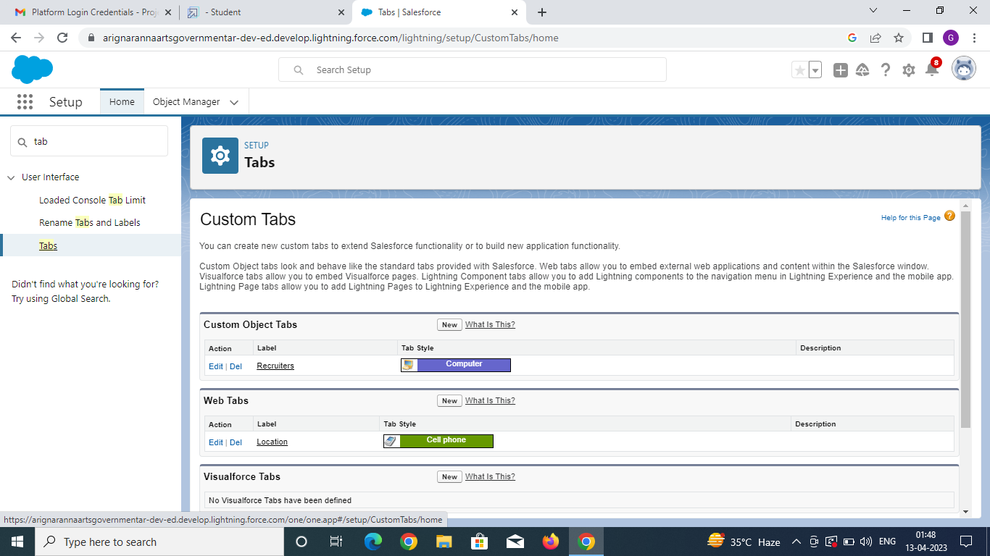

**Create a custom profile**

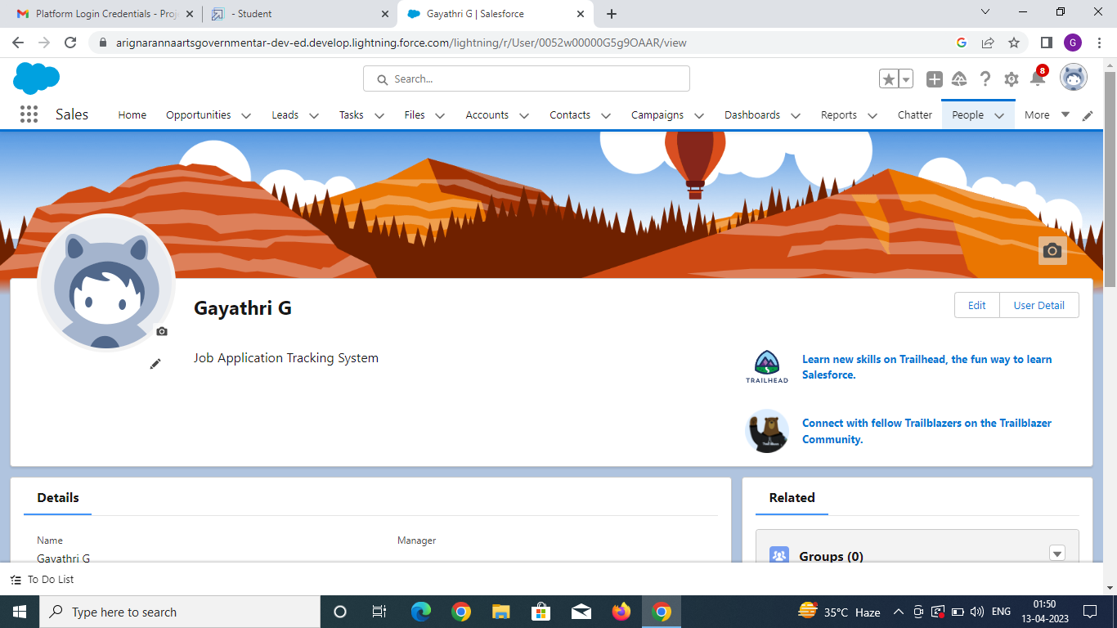

**To create a user**

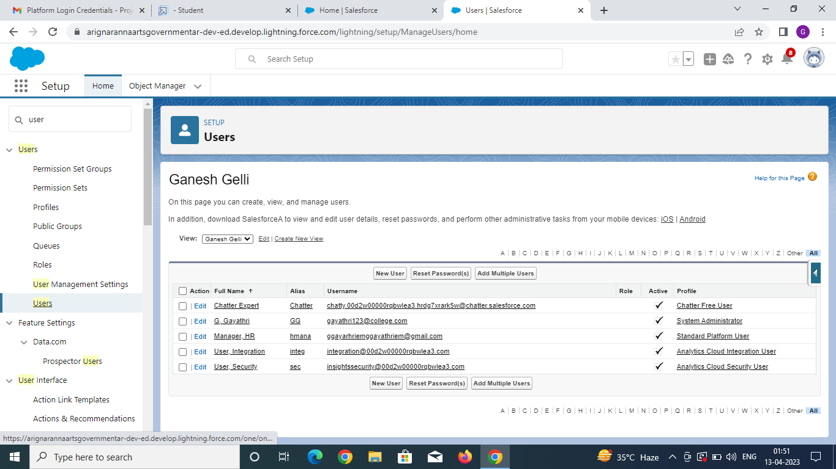

**Create a sharing rule**

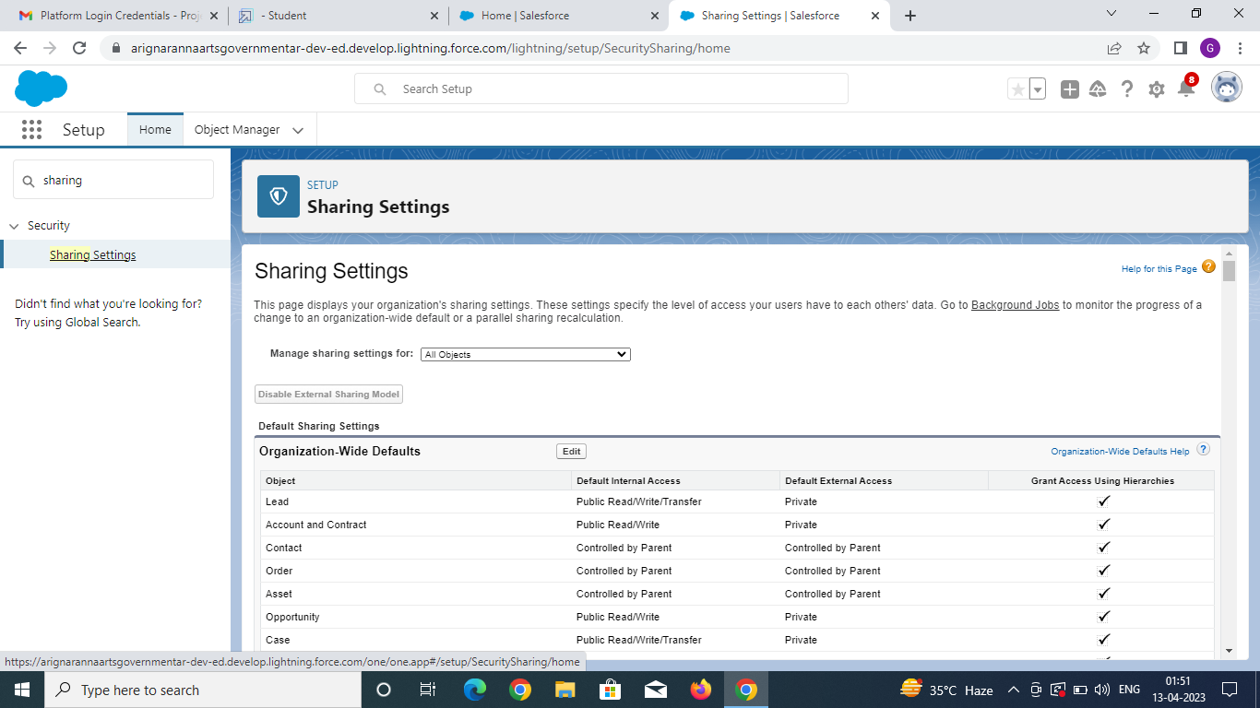

**Create a report**

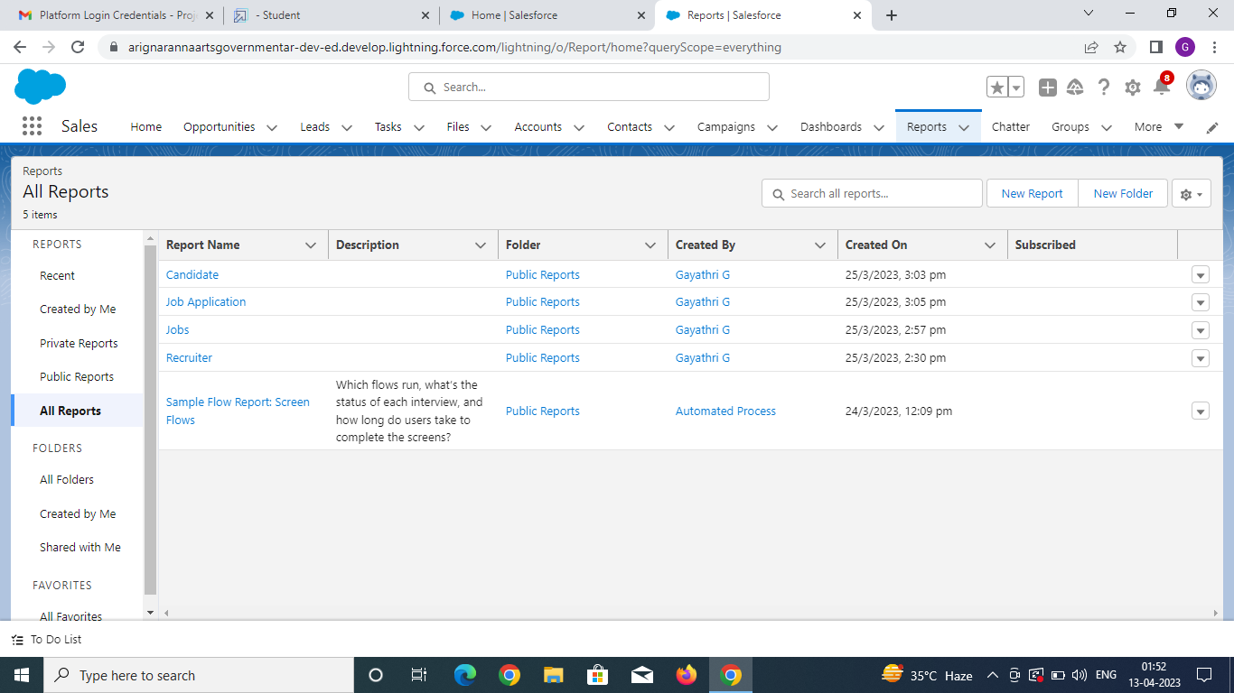

**4. Trailhead profile public URL**

# Team Leader- <https://trailblazer.me/id/gggayathriem>

# Team member 1- <https://trailblazer.me/id/vkotm>

**Team member 2-** [**https://trailblazer.me/id/kaviya2003**](https://trailblazer.me/id/kaviya2003)

**Team member 3-** [**https://trailblazer.me/id/pkavi20**](https://trailblazer.me/id/pkavi20)

**Team member 4-** [**https://trailblazer.me/id/**](https://trailblazer.me/id/)**kaItm10**

# 5. ADVANTANGES AND DISADVANTAGES

# ADVANTAGES

# An applicant tracking system (ATS) are most likely to quickly attract, identify and hire the best candidates. On the other hand, those who do not leverage new recruitment strategies and tools are certain to fail to achieve recruiting objectives. Here are some of the common benefits:

# 1. STREAMLINES RECRUITING

# An ATS enables you to manage your entire hiring process, from start to finish, on a single platform, so you don’t waste time juggling between multiple spreadsheets and tools to gather basic information. An ATS for small businesses helps achieve this easily by letting you manage job postings, interview scheduling, assessment, offer management, and onboarding all from the same place.

# 2. POSTS JOBS ON MULTIPLE JOB BOARDS

# Companies end up spending huge parts of their hiring budget on paid subscriptions to job boards like LinkedIn, Indeed, Monster to make sure that they attract the best candidates. While it is easy to find better candidates through these popular job boards, it can become time-consuming and expensive to juggle multiple job boards.

# 3. BUI LDS YOUR BRAND

# Whether you end up hiring a candidate or not, it’s crucial to make sure that they have a good experience while interacting with your organization in any manner. Good ATS can help you automatically notify candidates as they move through different stages of the interview process-you can notify candidates about their selection or rejection, reasons and guessing.

# 4. PROMOTES EASY COLLABORATION AMONG THE RECRUITING TEAMS

# ATS makes it possible to reduce the chaos that comes with hiring for multiple positions and teams. Everyone involved in the hiring process has access to the candidate interview transcript, assessment score, resume, information about their previous experience and other information required to make the right hiring decisions together, quickly.

# DISADVANTAGES

# An applicant tracking system is that they are open to manipulation. Automatic elimination of resumes that software cannot recognize and interpret is another drawback of ATS.

# 1. ONLINE JOB MARKET

# The candidate may also have a hard time gauging whether the company is the right place for her. Without the opportunity for the employer to hold multipl1e in-person interviews, it can be difficult to determine if the candidate will be a good fit for the company and its culture.

# 

# 2. A CAMPUS RECRUITMENT

# Companies in different expenses related to travel, boarding, training etc. while conducting campus selection process. The experienced and skilled candidates having practical job exposures cannot be recruited through campus placements.

# 3. DATA RECORDS

# The process of evaluating documents and records can be time-consuming can be an incomplete data collection method because the researcher has less control over results. Some documents may be not publicly available. Information may be out of date or inapplicable.

# 4. EMPLOYMENT

# The con of full-time employment may be difficult balancing your personal life to comfortable in your routine. You resume may lack versatility. The cons of full-time employment may be experience more work-related stress.

# APPLICATION

# An applicant tracking system (ATS) is software for recruiters and employers to track candidates throughout the recruiting and hiring process. This software can come equipped with capabilities ranging from simple database functionality to a full-service suite of tools that makes it easy for businesses of any size to filter, manage, and analyze candidates.

# 1. SOURCE AND ATTRACT QUALIFIED CANDIDATES

Some organizations lack the reach to connect with top job seekers or to a cast a wide enough net in the marketplace. Others are missing critical data on the right channels to find specific candidates; other organizations may lack brand recognition and the means to develop it. An ATS can help address these critical candidate challenges.

#### 2. INCREASE CANDIDATE ENGAGEMENT

Moving a candidate through the journey from first contact to start date can be a high-touch process. It can be all too easy to lose a top candidate because of slow response times or poor engagement around interview schedules. An ATS creates greater visibility across the applicant lifecycle, so touch points don’t fall through the cracks.

#### 3. IMPROVE EFFICIENCY AND LOWER COSTS

A reliance on inefficient manual processes, poor collaboration across the recruiting team, and miscommunication with key hiring stakeholders means that applicants move slowly through the hiring process. This leads to high cost-to-hire and time-to-hire ratios. An ATS creates opportunities to automate manual processes, increase visibility into the hiring cycle for the entire recruiting team, and increase opportunities for communication throughout the candidate journey.

**CONCLUSION**

Applicant Tracking System for recruiters is a very effective hiring solution that most of the successful recruiters utilize. Because without it, there is a good chance that your process of moving applicants through different stages can become very difficult. Employers can reduce their dependence on decentralized, paper and email processes.

**FUTURE** **SCOPE**

The world is moving into automation and AI, and leads way to the new age Applicant Tracking System (ATS). Read further to understand what the future might be like for the ATS.